MAKERFEST_3.O submitted by EE25B133 Soumyadeep Das
Tasks: GitHub https://github.com/sdas5648/Makefrest-3.O-round-2/
- Fix the bug:
Reason: the previous code only handled collision of ball and paddle when it hits the upper side. There’s no code to handle the side collisions. Also the direction of the ball before collision isn’t specified. So it behaves like that.
Fix:
// Paddle collision
//top side
if (ballX > paddleX && ballX < paddleX + paddleWidth
&& ballY + ballSize >= paddleY
&&ballSpeedY>0 && ballY<paddleY) {
ballSpeedY = -ballSpeedY;
score++;
showScore();
}
//left side
else if (ballY>paddleY && ballY<paddleY+paddleHeight
&& ballX+ballSize>=paddleX
&& ballSpeedX>0 && ballX<paddleX) {
ballSpeedX=-ballSpeedX;
}
//right side
else if (ballY>paddleY && ballY<paddleY+paddleHeight
&& ballX-ballSize<=paddleX+paddleWidth
&& ballSpeedX<0 && ballX>paddleX+paddleWidth) {
ballSpeedX=-ballSpeedX;
}
For all of the top, left and right side collisions, i have specified pre-requisite velocity directions.

- Scoreboard: (The github repo we had been given already had the scoreboard implemented in it.)
- Bouncing balls:
To add a second ball, I used the class ball to generate the second ball ball2.
The collisions with walls were as usual. For collision among the balls, I exchanged the velocities of the ball, assuming they were of the same mass and coefficient of restitution=1.
To check if collision==true, i checked the distance between them,
And applied dist <= ball1.size + ball2.size;
// Ball collision
- float dx = ball2.x - ball1.x;
- float dy = ball2.y - ball1.y;
- float distance = sqrt(dx * dx + dy * dy);
- if (distance <= ball1.size + ball2.size) {
- // Simple elastic collision response, assuming equal mass
- float tempSpeedX = ball1.speedX;
- float tempSpeedY = ball1.speedY;
- ball1.speedX = ball2.speedX;
- ball1.speedY = ball2.speedY;
- ball2.speedX = tempSpeedX;
- ball2.speedY = tempSpeedY;
- }
4. Collision with rect:
A. Left n Right Sides(already demonstrated)
B. Top n Bottom sides (similar to above)
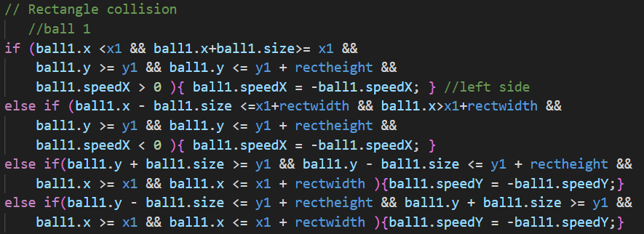
C. Corners: To check if the ball hits the corners, i checked the dist between their centre and the corner’s coordinates.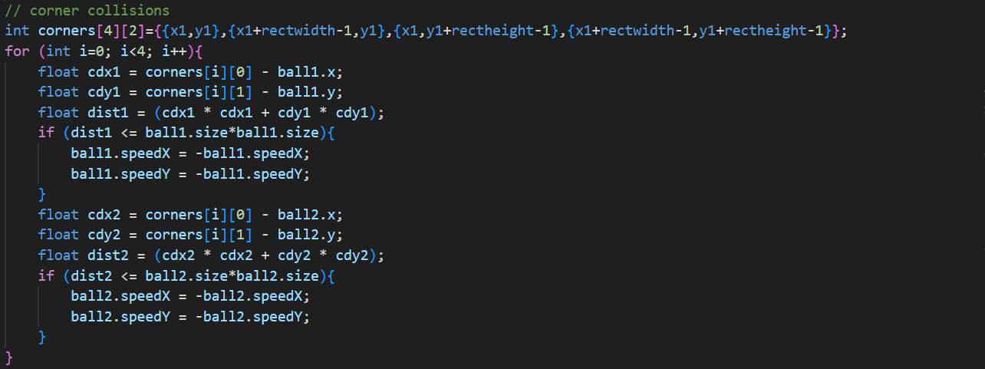
5. Collision with slanted rect: to detect the collision with one side of a slanted rectangle defined by the coordinates x1,y1 x2,y2 x3,y3 x4,y4 i tried to use geometric logics as follows
#define x1 150 #define y1 50
#define x2 175 #define y2 75
#define x3 75 #define y3 175
#define x4 50 #define y4 150
//line 1: y=x-100 using x1,y1,x2,y2
//line 2: y=-x+250 using x2,y2,x3,y3
//line 3: y=x+100 using x3,y3,x4,y4
//line 4: y=-x+200 using x4,y4,x1,y1
Logic:
Each of the following code snippets is implemented for each line once.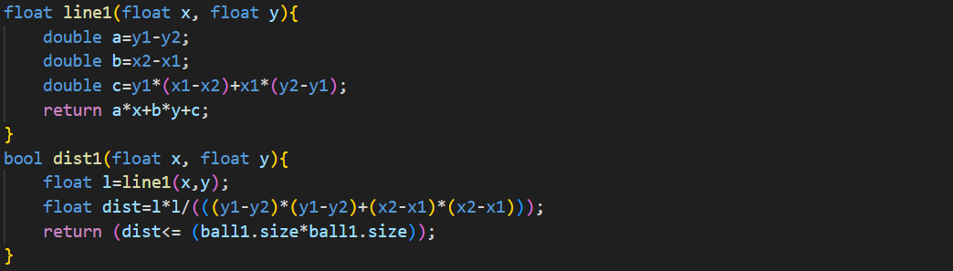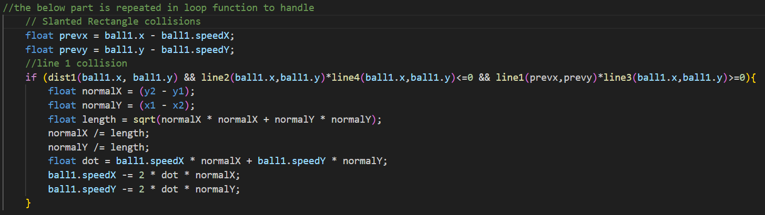
I tried using the product of line values to restrict the position, incoming velocity before collisions, as if i had used only distance between ball and line, it might have produced bug, also using product of line values instead of checking each line gives us the flexibility of modifying only the coordinates or corner points, otherwise we would have to modify the logic with respect to each line individually.
Unfortunately, it didn’t work.
Then I asked Claude.ai to modify the code. Using that i modified the code as following
https://github.com/sdas5648/MakerFest_3.O/blob/main/CLAUDE.CPP
6. Snake game:
https://github.com/sdas5648/Makefrest-3.O-round-2/tree/main/snake%20game
A. drawsnake: to draw the body of the snake, i identified each of the element/block of the snake by its top-left corner coordinate of the rectangle. I defined struct point{int x;int y;}; to include the corner coordinates into a struct defined by point snake;
Now to draw the snake, i draw a rectangle of fixed size about each of the point in snake;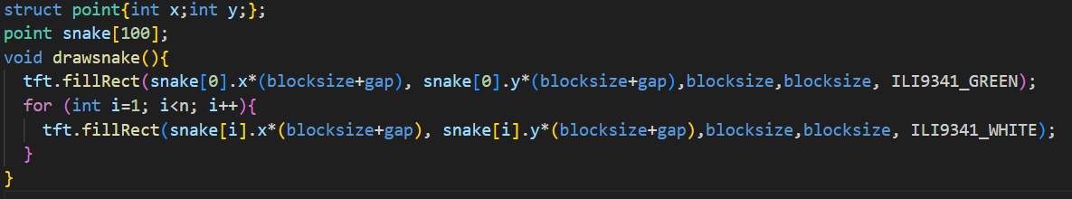
//blocksize=8,gap=2 pixels
B. Moving the Snake: to move the whole body of the snake, i defined direction tokens as dirX=1;dirY=0; (by default, these will change due to buttonActions). So after each predefined-interval i deleted the last point from the struct snake and add the new point corresponding to the direction token values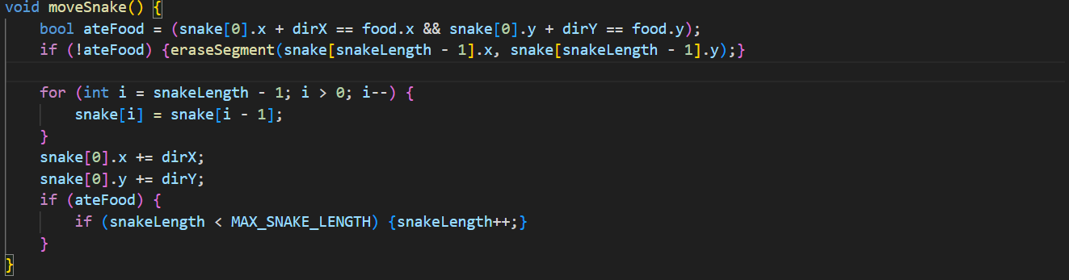
C. Button Actions: to read the button press, i used INPUT_PULLUP as the pinmode. To ignore the frequent button presses, I used millis() and a pre-defined delayperiod.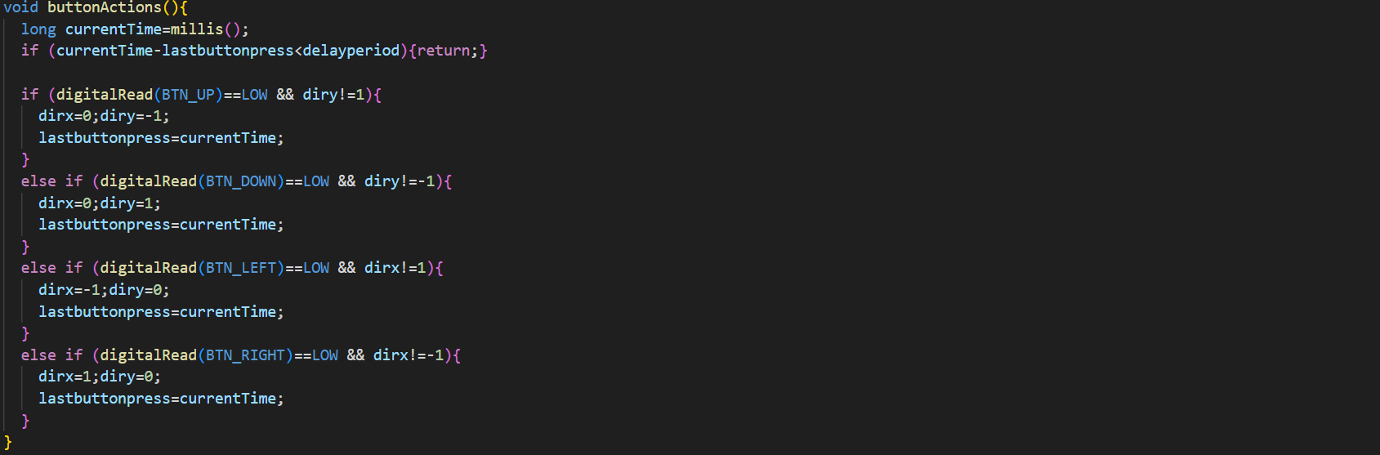to avoid 180deg turns, i used that condition in if/elseif condition statements.

D. Food Genaration: to generate food i defined another struct point food; and added randomly generated food coordinates into the struct, but to make sure it didn’t coincide with the snake’s body, i drew the food in the same way with the snake’s blocks, i.e. the top-left corner
Then i checked if the generated food coordinates coincide with any point in the struct snake;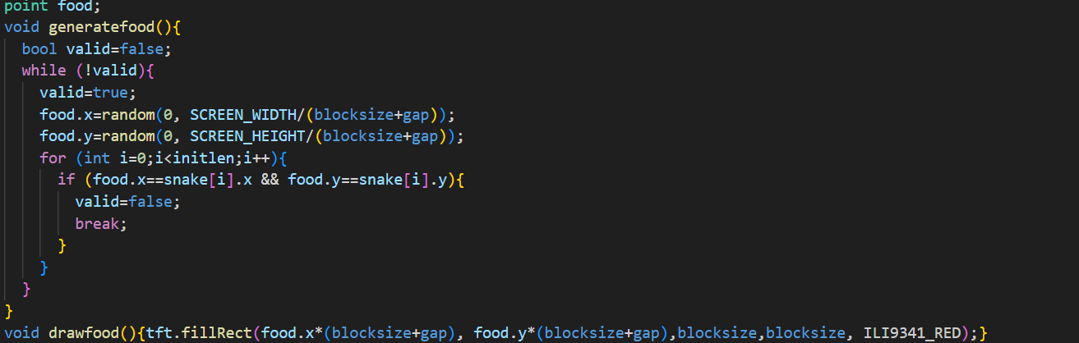
E. Eating food: to detect the collision of food and snake’s head, I used
bool ateFood = (snake[0].x + dirX == food.x && snake[0].y + dirY == food.y);
if (!ateFood) {eraseSegment(snake[snakeLength - 1].x, snake[snakeLength - 1].y);}
In the movesnake(); part.

F. Collision Detection: I simply checked if the coordinates of the snake’s head i.e. snake[0].x, snake[0].y coincide with itself or crosses the boundary. Also i defined a boolean gameover=false by default previously so that whenever the snake collides with itself or the wall, it handles the gameover conditions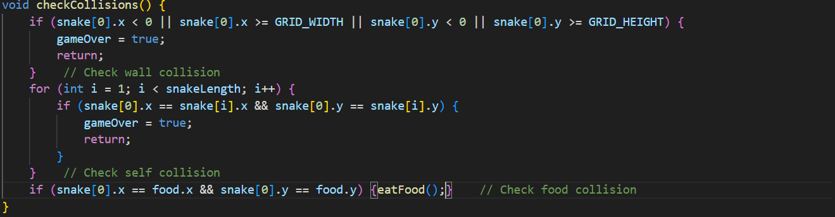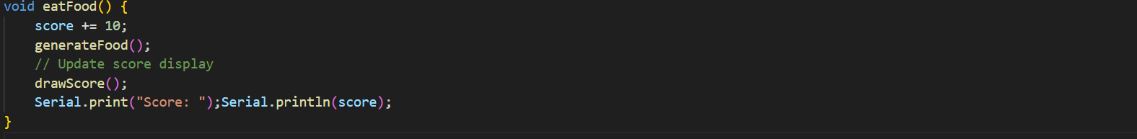

G. Game Over: to handle gameover, i implemented the function handlegameover() whenever the bool gameover=true.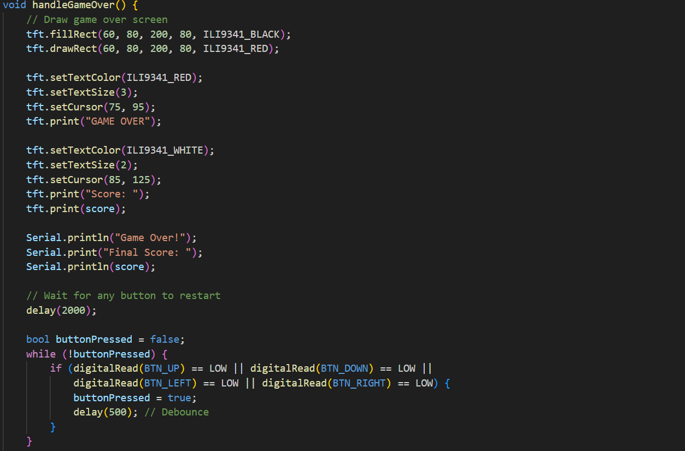
H. initialize game:
To start the game, I used initlen=3; and generated a snake from the middle of the grid.